

**The A Team**

**Image Processing Tool for**

**Leidenfrost-Ratchet Systems**

**User Manual for Version 2.0 (Final Draft)**

April 20, 2015

**Authored By:**

Sanan Aamir

Romando Garcia

Anne Lam

James Rowe

Hieu Tran

Table of Contents

1. Introduction 2
2. Overview 2
3. What's New in Version 2.0. 2
4. System Summary 3
   1. System Requirements 3
   2. System Installation 3
   3. Flow of Data. 3
5. Using the System 4
   1. Getting Started 4-6
   2. Running the Application(Step-by-step instructions) 6-12
6. References. 13

Document Revision History

|  |  |  |  |
| --- | --- | --- | --- |
| **Version Number** | **Date** | **Contributor** | **Description** |
| V1.0 | 4/12/2015 | Author: Hieu Tran  Reviewers: Rest of  A-Team | First draft of User Manual |
| V2.0 | 4/28/2015 | Authors: Anne Lam and  Hieu Tran | Revisions and new screen shots |

**1. Introduction**

The purpose of the software is to efficiently track a drop of liquid and record measurements through images gathered from a high speed camera as the drop falls from an injection needle and travels along a ratchet surface.

This User Manual provides all the necessary information to achieve that purpose through use of the Image Processing Tool. The Manual first lists any system requirements, then details the installation process, and finally explains how to navigate the tool and perform the processing functions.

**2. Overview of Document**

This User Manual is a complete guide on how to use the Image Processing Tool. More specifically, this document provides the users of the Image Processing Tool with information on how to install, run, and possibly troubleshoot the provided software.

The primary users of this document will be researchers involved in tracking the motion of a droplet as it falls onto a ratcheted surface. The group of researchers who will use this software includes but is not limited to: Dr. Ok and Dr. Guo.

Finally, this User Manual applies only to the Image Processing Tool Version 2.0 supplied by the A-Team.

**3. What's New in Version 2.0**

Version 2.0 of the tool includes a completely new design, removing the initial form for loading the 'clear field' image, and only encompassing buttons for loading, saving, and running, three adjustable parameter fields, and a single image displayer. The instructions on how to run the tool are given below in Section 5.

In addition to the cleaner, simpler interface, Version 2.0 produces more meaningful processed images which show the Tool's analysis overlaid on top of the original image so that accuracy can be better visualized.

Finally, output now includes net measurements for velocity and acceleration, as well as drop volume. All the data is automatically displayed on generated graphs.

**4. System Summary**

This section informs the user about what system requirements are needed, how to install the Image Processing Tool and what data to expect from the tool.

4.1 System Requirements

Before installing the Image Processing Tool, please ensure that your system meets the following requirements.

- Includes Windows 7 Professional or newer

- Includes Excel 2007 or newer

4.2 System Installation

To install the Image Processing Tool using the CD-ROM:

1. start Windows;
2. insert the software CD;
3. copy the file labeled ImageProcessingTool.exe on to the hard drive;
4. create a Shortcut to the ImageProcessingTool.exe on your desktop by right clicking the file and then select 'Send to Desktop as a shortcut';
5. finally, double click the shortcut to run the Program.

4.3 Flow of Data

The user shall load their desired folder of images, enter in known parameters, and run the software. While the tool is running, centroid, velocity, acceleration, and volume are being calculated for each image. This data will be organized in an Excel spreadsheet and graphically represented in nine different graphs. In addition, a folder for the processed images will be created, with the same name as the data folder, with "_processed" appended to it. This folder will contain the processed images with the analyzed base, needle, and drop drawn on top of the original image.

**5. Using the System**

This section informs the user on how to use the Image Processing Tool through step by step instructions with accompanying screen shots.

5.1 Getting Started

1. Opening the Application:

Double click on the ImageProcessingTool.exe icon to open the application.

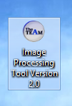

2. Understanding the User Interface:

There is a single form that will let the user Load the folder of images, name the output Excel file, calibrate the process images, enter known inputs(frames per second, base to needle height(cm), and finally run the complete data set. The program will automatically generate an Excel file at the end of processing. This file will contain several spreadsheets: the raw data and its accompanying graphs.

To provide additional assistance, the load and browse buttons have tool tips which appear on hover, and the input fields have tool tips(question marks) by their labels.

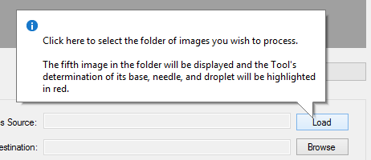

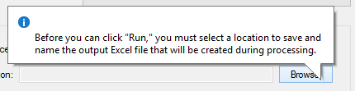

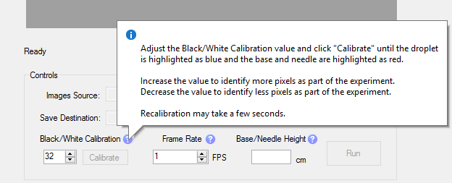

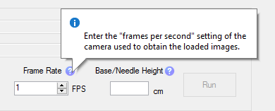

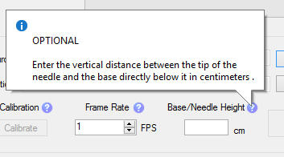

5.2 Running the application (Step-by-step Instructions)

This section shows how to use the Image Processing Tool through step-by-step instructions with screen shot images for clarity.

1. Loading the Image Folder:

Click on the Load button. A "Browse For Folder" Dialog will appear.

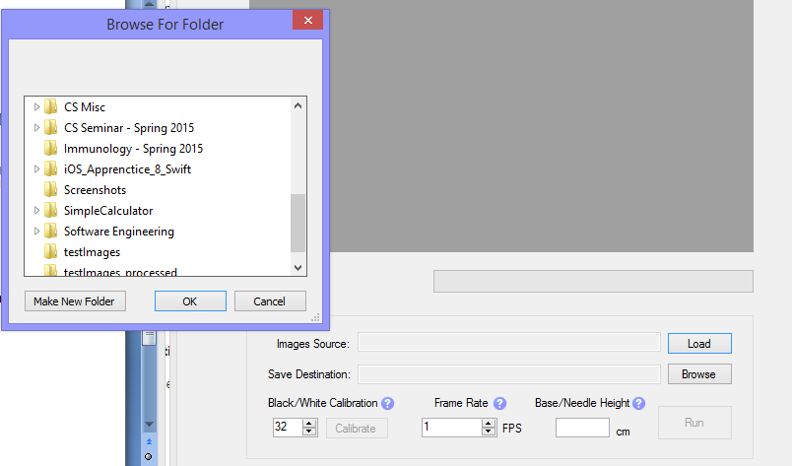

Navigate through the folders to find and select the correct image folder, and then click Ok.

The fifth image will be processed and displayed. The base and needle will be shown in red, the droplet will be show in blue, and the circumference of the droplet will be in white.

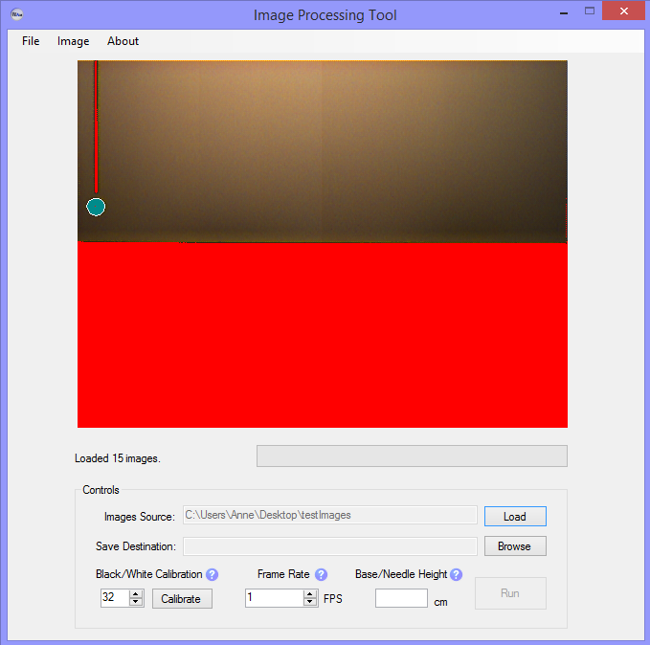

2. Naming the output file:

Click the Browse button. A "Save As" Dialog will appear.

Navigate to the desired saving location.

Name the file and select save.

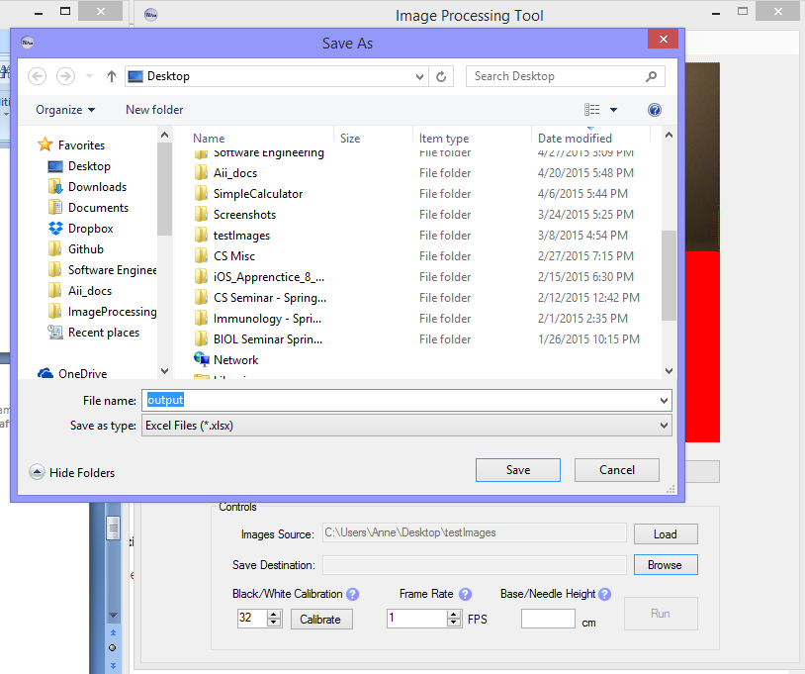

The path/name of the file will show.

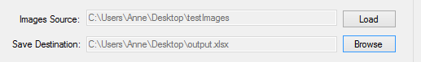

3. Optional: Calibrating the displayed image:

Under "Black/White Calibration," Enter/Select any value above 32 to consider more pixels as part of the experiment.

Under "Black/White Calibration," Enter/Select any value below 32 to consider less pixels as part of the experiment.

You may enter any integer between 0 and 255.

4. Enter Frame Rate (FPS)

Enter the camera frame rate in frames per second. Must be greater than 0.

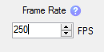

5. Enter the Base/Needle Height (Optional)

Enter the vertical height from the needle to the ratchet base directly below in centimeters, if known.



6. Click Run

Click the Run button. It will then turn into a Stop button.

 

7. View the data

Look through the data displayed in the Excel file that opens and determine if it is acceptable.

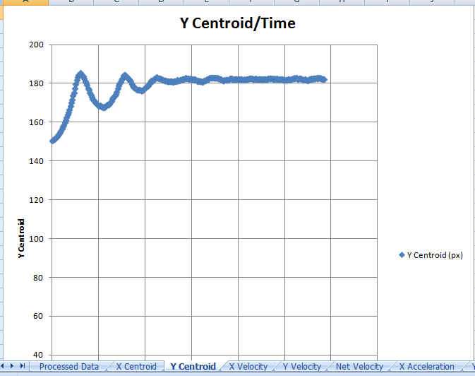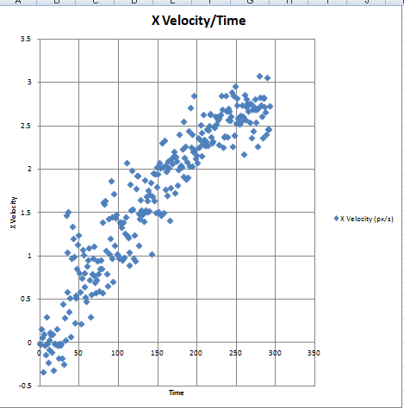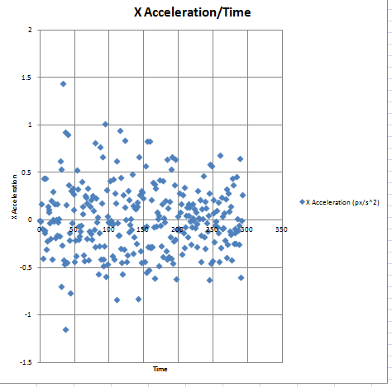

If the data seems unreasonable, you may choose to go back to the Image Processing Tool and recalibrate before re-running, or you may wish to neglect that data set and upload another folder of images to run.

8. View the processed images that were saved in a folder of the same name as the image source folder, but with '_processed' appended to it.

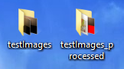

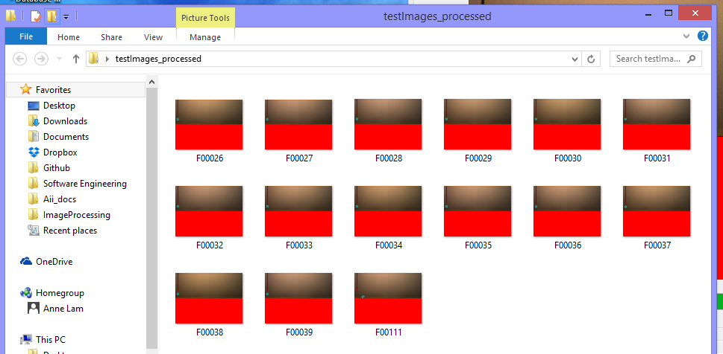

9. Utilize the Menu Strip to do the following:

Click File to Load Images or Quit the Application

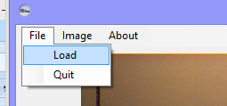

Click Image to Run the Data (once you've also named the output file).

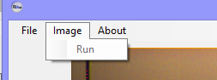

Click About to get some info about the Tool's creators.

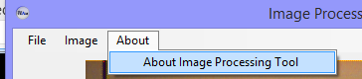

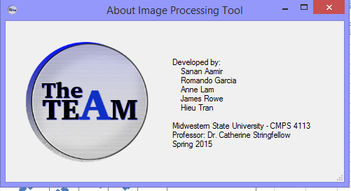

**6. References**

This User Manuel was written with guidance from the User Guide Outline written by Dr. Catherine Stringfellow.